PYTHON WEB SCRAPING AND SELENIUM
ASSIGNMENT

https://www.census.gov/quickfacts/fact/table/

Take the County Name and State name from this sheet and put the county name in search filed and find the result which contains county name and state name and select that.

like in the sheet we have a Alabama as State Name and Winston a County Name, So put the Winston in search field, Then wait for the query results and find the results value contains the value of Alabama and Winston and then click on it and scrape the further fetched data from page.

In this we can see that the 3rd result full fill our requirement and has a exact keywords (State and County).
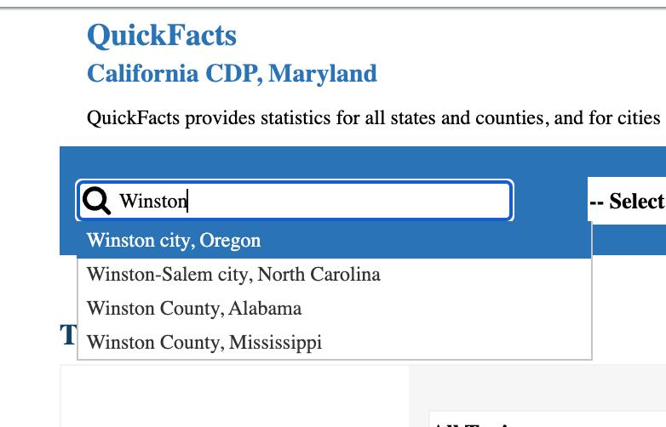.

This is the sample output JSON we need to create.

Required Libraries:
- os: Provides a way to interact with the operating system.
- selenium: A web automation framework used to control web browsers.
- pandas: A data manipulation library.
- json: For handling JSON data.

This script performs web scraping using Selenium to extract data from the U.S. Census Bureau's QuickFacts website.
It navigates through specified county and state combinations to retrieve population data and other statistics.

CSV Filr:
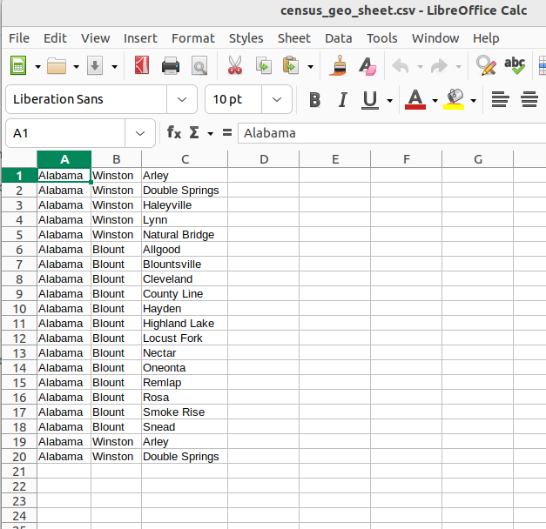

Code:

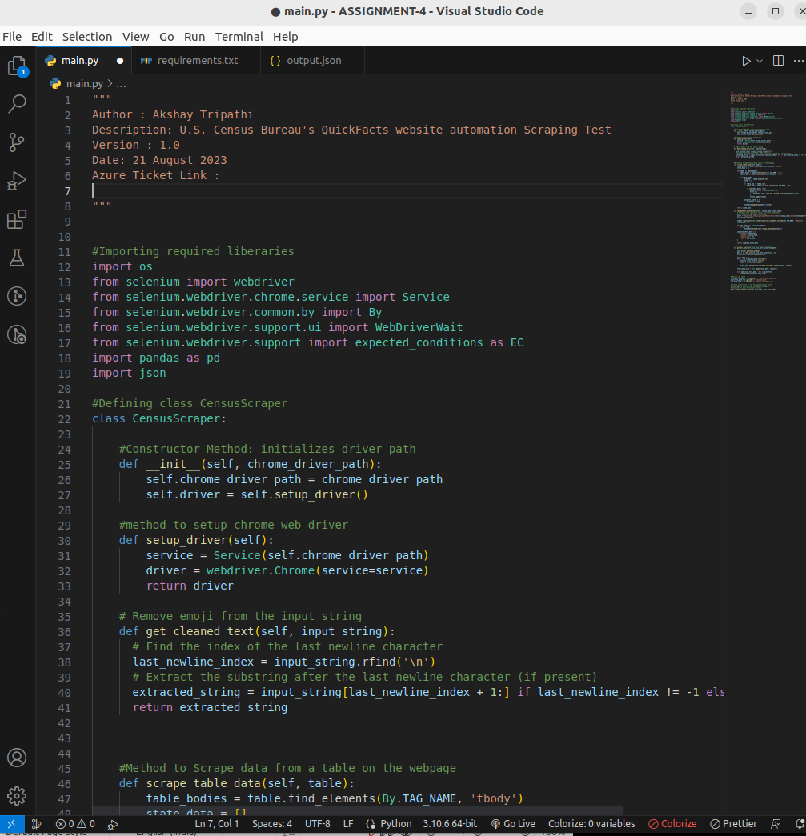
.
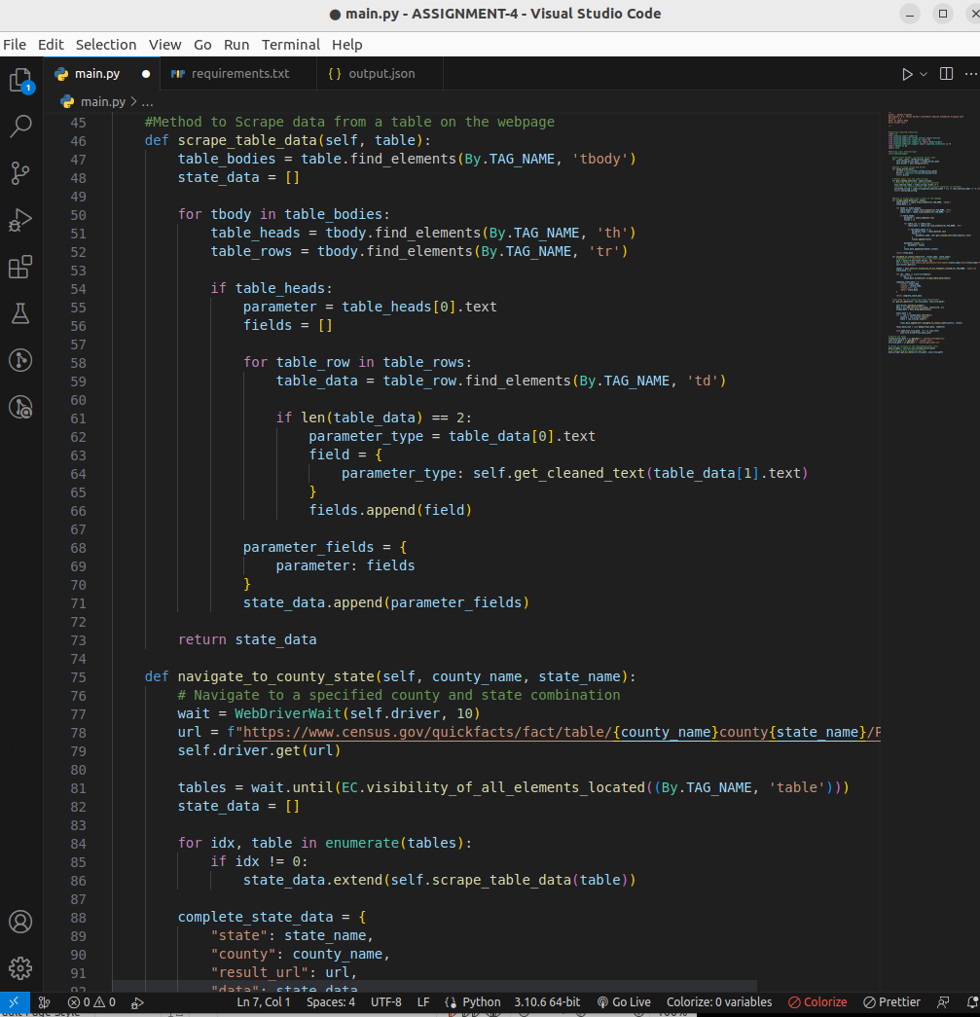
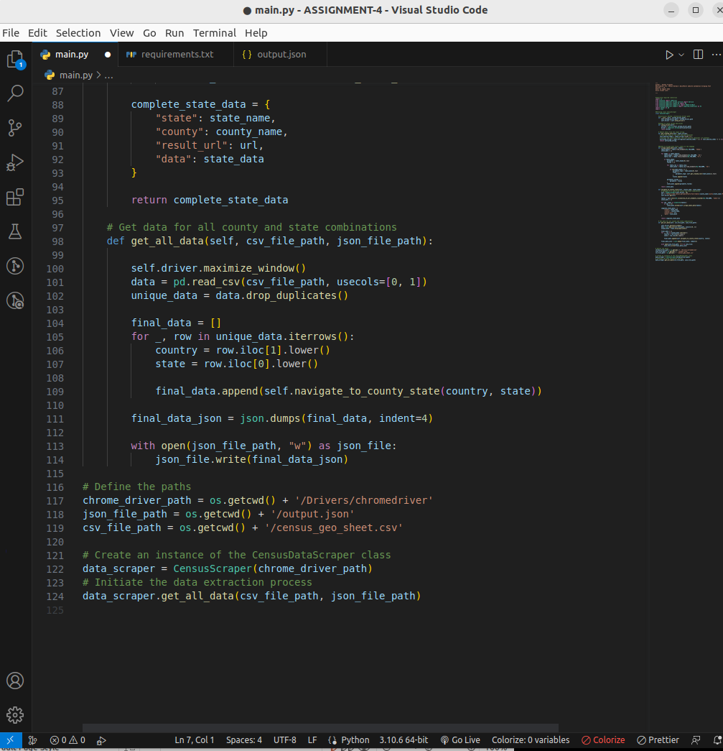

Output:


